Decay Factor –
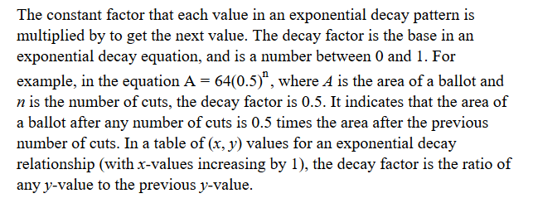
Exponential Decay –
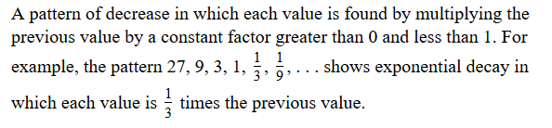
Decay Rate –
