GGG 2.2 – 2.3 p. 29-31 Name _______________ Per _______
Don’t forget – HW check Thursday on GGG 2.2. GGG Inv. 2 HW is all due on Friday, 11/13.
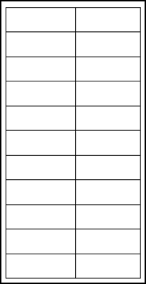
Using the equation m = 50(3^{d}) (where m = the area of mold in mm² and d = the number of days), answer the questions. Fill in the table at the right to help you.

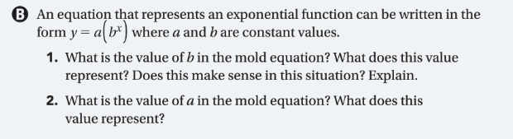

2.3
Year | # Snakes
0
1
2
3
4
5
