Exponential Functions
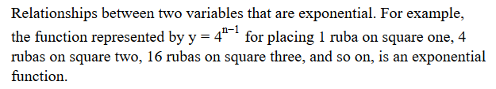
Exponential Growth
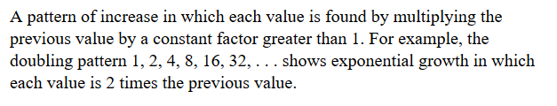
Growth Factor
