Base 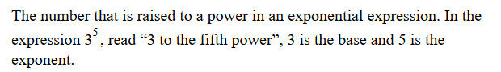
Exponent
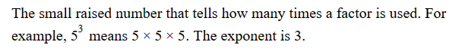
Exponential Form
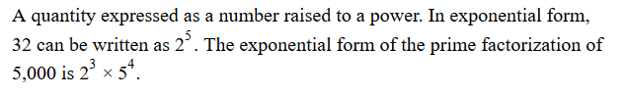
Scientific Notation
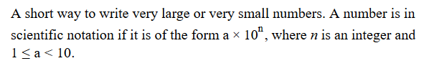
Standard Form
